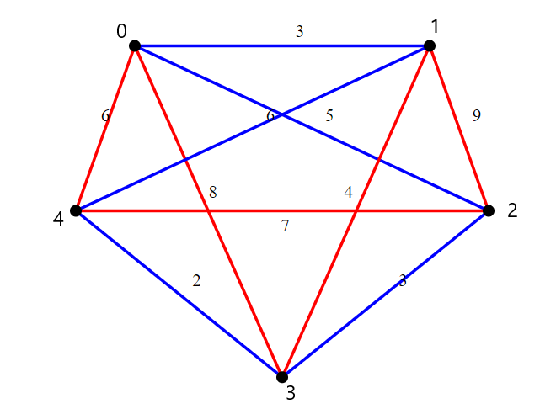**Assignment No. 5** Truta David Cristian

**Graph with 5 vertices:**

**Ordered Edges:**

**(3, 4) 2  
(0, 1) 3  
(2, 3) 3  
(1, 3) 4  
(0, 2) 5  
(0, 4) 6  
(1, 4) 6  
(2, 4) 7  
(0, 3) 8  
(1, 2) 9**

**We add edges that don’t complete a cycle that includes all vertices AND that never have more than 2 edges meeting at a vertex:**

**It1: (3,4) is added**

**It2: (0,1) is added**

**It3: (2,3) is added**

**It4: (1,3) is not added (more than 2 edges meeting at a vertex)**

**It5: (0,2) is added**

**It6: (0,4) is not added (completes a cycle that doesn’t have all the vertices)**

**It4: (1,4) is added (completes a cycle that has all the vertices) 🡪 Algorithm stops here**

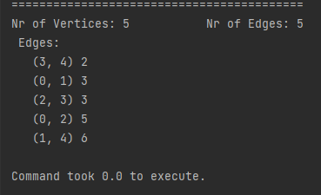

Input File:

5 10  
0 1 3

3 4 2  
2 3 3  
1 3 4  
1 4 6  
2 4 7  
0 3 8

0 4 6  
1 2 9

0 2 5

**The two graphs:**

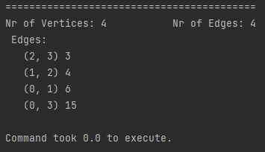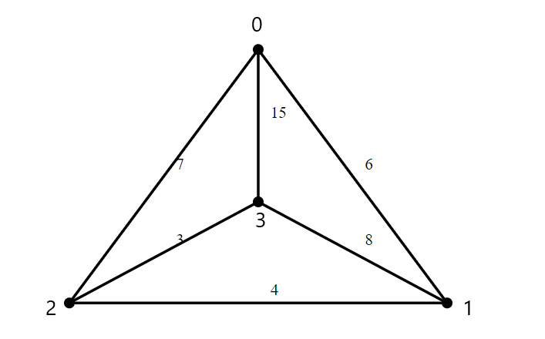**1.**

Input File:

4 6  
0 1 6  
1 2 4  
0 2 7  
0 3 15  
2 3 3  
1 3 8

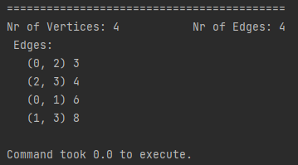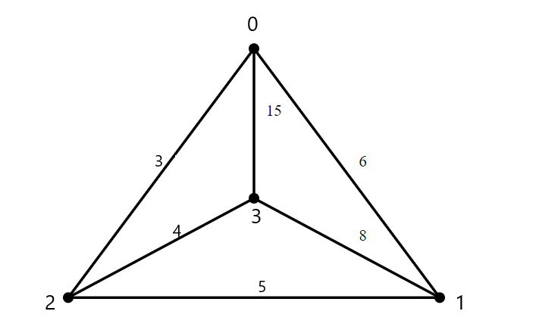**2.**

Input File:

4 6  
0 1 6  
1 2 5  
0 2 3  
0 3 15  
2 3 4  
1 3 8